Question 1
Q. : How do you handle forms in React? Explain the concept of controlled components.
Ans : Handling Forms In React:
- Forms In React Are Managed By Storing Input Values In State.
- Every Time The User Types, An Event Updates The State.
- The Component’s State Becomes The Single Source Of Truth For The Input Value.
Controlled Components:
- A Controlled Component Is An Input Element Whose Value Is Controlled By React State.
- The value Attribute Of The Input Is Set From State, And onChange Updates That State.
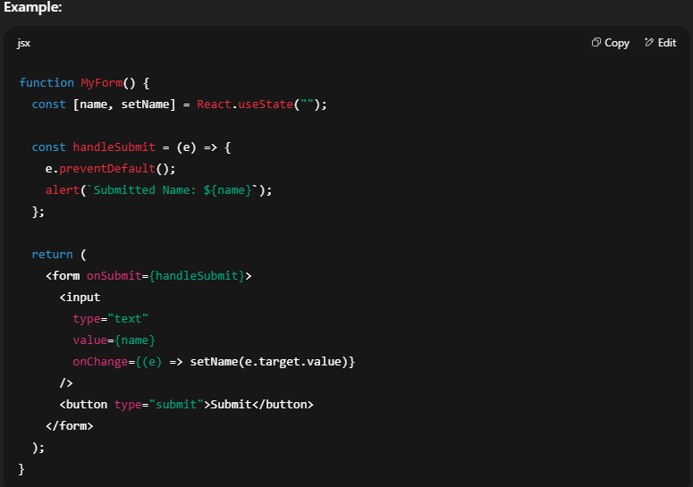
Question 2
Q. : What is the difference between controlled and uncontrolled components in React?
Ans :
Feature | Controlled Component | Uncontrolled Component
Value Source | React State | DOM (HTML Element Itself)
Data Handling | State Is Updated On Every Change | Value Accessed Using ref
Single Source Of Truth | Yes | No
Best For | Validation, Dynamic Updates, Complex Forms | Simple, Non-Interactive Inputs
Example | <input value={state} onChange={...} /> | <input defaultValue="Hello" ref={myRef} />

